Packet Tracer - Skills Integration Challenge

1. Topology

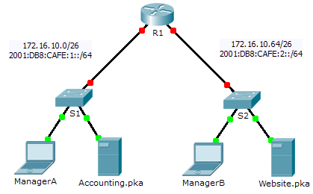

1. Addressing Table

|  |  |  |  |  |
| --- | --- | --- | --- | --- |
| Device | Interface | IPv4 Address | Subnet Mask | Default Gateway |
| IPv6 Address/Prefix | |
| R1 | G0/0 | 172.16.10.1 | 255.255.255.192 | N/A |
| 2001:DB8:CAFE:1::1/64 | | N/A |
| G0/1 | 172.16.10.65 | 255.255.255.192 | N/A |
| 2001:DB8:CAFE:2::1/64 | | N/A |
| Link-local | FE80::1 | | N/A |
| S1 | VLAN1 | 172.16.10.62 | 255.255.255.192 | 172.16.10.1 |
| S2 | VLAN1 | 172.16.10.126 | 255.255.255.192 | 172.16.10.65 |
| ManagerA | NIC | 172.16.10.3 | 255.255.255.192 | 172.16.10.1 |
| 2001:DB8:CAFE:1::3/64 | | Fe80::1 |
| Accounting.pka | NIC | 172.16.10.2 | 255.255.255.192 | 172.16.10.1 |
| 2001:DB8:CAFE:1::2/64 | | Fe80::1 |
| ManagerB | NIC | 172.16.10.67 | 255.255.255.192 | 172.16.10.65 |
| 2001:DB8:CAFE:2::3/64 | | Fe80::1 |
| Website.pka | NIC | 172.16.10.66 | 255.255.255.192 | 172.16.10.65 |
| 2001:DB8:CAFE:2::2/64 | | Fe80::1 |

1. Scenario

Your company has won a contract to set up a small network for a restaurant owner. There are two restaurants near each other, and they all share one connection. The equipment and cabling is installed and the network administrator has designed the implementation plan. You job is to implement the rest of the addressing scheme according to the abbreviated Addressing Table and verify connectivity.

1. Requirements

* Complete the **Addressing Table** documentation.
* Configure **R1** with IPv4 and IPv6 addressing.
* Configure **S1** with IPv4 addressing. **S2** is already configured.
* Configure **ManagerA** with IPv4 and IPv6 addressing. The rest of the clients are already configured.
* Verify connectivity. All clients should be able to ping each other and access the websites on **Accounting.pka** and **Website.pka**.

1. Suggested Scoring Rubric

Packet Tracer scores 80 points. Completing the **Addressing Table** is worth 20 points.